Bungamati
Mukesh from Bungamati feels safe and secured in the small tin roofed hut
Mukesh Shakya is one of the earthquake victims in Bungamati. He is a hard working carpenter.. Before the earthquake he was living at Warpwa, Bungamati of ward 3 with his parents. When he got married with a girl who is from different caste, his parents didn’t allow him to live in the same house. o he was out of the house for 3 years and living in a rented room with his wife and son.
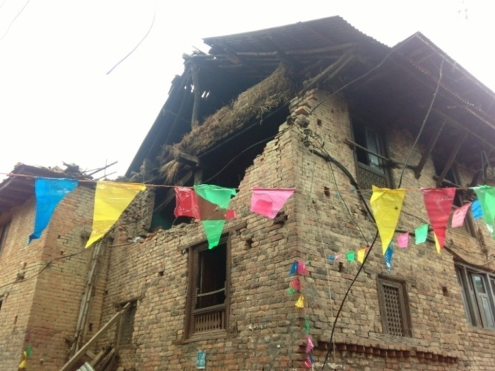
The earthquake on 25 April 2015 destroyed his family house. The house he was living was also fully damaged. So they had to live in a tent fixed in other’s field. When the CLC made study on situation of households, we found them having problem with his family. They hardly expressed how their parents badly treated for their inter caste marriage. Considering his problem, our CLC decided to provide him a temporary shelter supported by NRC-NFE.
Mukesh is now living happily in the tin roofed hut with his wife and son. Their daily life became more easier than before. When they were living under the tarpaulin, they had to face leakage of water during rain. There was no way to lock their home, when they had to go somewhere out. But now, they can go anywhere without fear of theft. There is no leakage from the roof. So, they feel much safe and secured in the hut. He is very much grateful to Amarapur CLC and NRC- NFE and thanked for helping him.
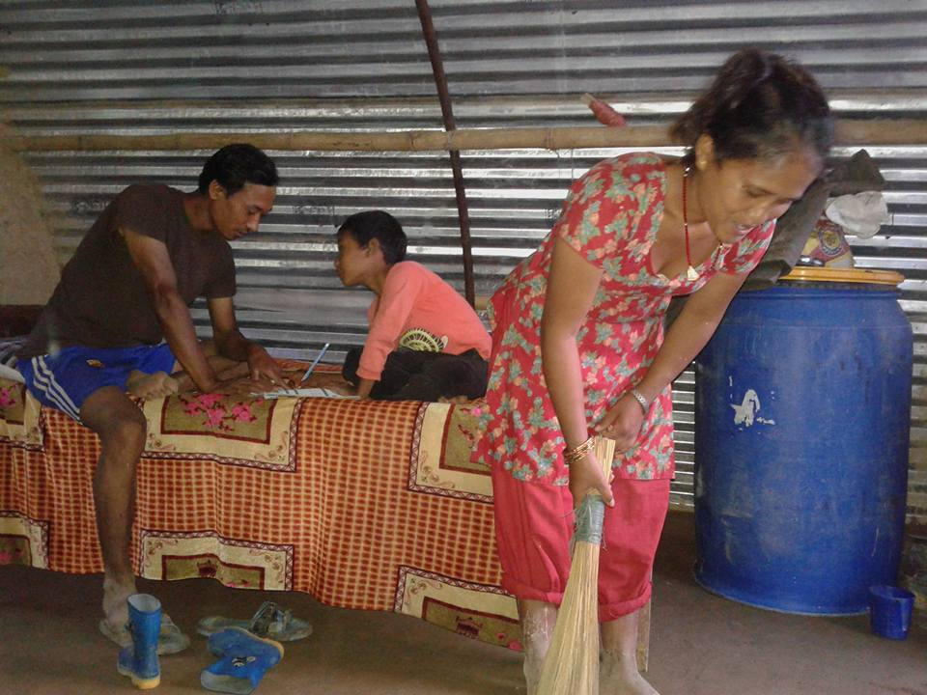
Mukesh Shakya's Family

